Software Requirements Specification

For MotelPRO Project

Version 1.0 approved

Prepared by:

Hemanth kumar Kaluvakuri

Prathyusha Dasari

SriHarsha Jaligama

Rahul Reddy Kanmanthanreddy

Anurag Matyapwar

Date Created: 09/30/2020

Table of Contents

1. Introduction................................................................................................................................. 1

1.1 Purpose ............................................................................................................................... 3

1.2 Document Conventions............................................................................................................. 3

1.3 Intended Audience and Reading Suggestions............................................................................................................................ 3

1.4 Project Scope.... .................................................................................................................. 3

1.5 References............................................................................. .............................................. 4

2. Overall Description............................................................................................................................. 4

2.1 Product Perspective............................................................................................................................... 4

2.2 Product Features................................................................................................................................... 5

2.3 User Classes and Characteristics......................................................................................................................... 6

2.4 Operating Environment............................................................................................................................ 6

2.5 Design and Implementation Constraints............................................................................................................................... 7

2.6 User  Documentation................................................................................................................. 7

2.7 Assumptions and Dependencies.................................................................................................………………….7

3. System Features.....................................................................................................................................7

4. External Interface Requirements.....................................................................................................………..9

4.1 User Interfaces.........................................................................................................................9

4.2 Hardware Interfaces................................................................................................................. ……..11

4.3 Software Interfaces................................................................................................................... 11

4.4 Communications Interfaces....................................................................................................... 11

5. Other Nonfunctional Requirements............................................................................................ 12

5.1 Performance Requirements....................................................................................................... 12

5.2 Safety Requirements................................................................................................................. 12

5.3 Security Requirements.............................................................................................................. 12

5.4 Software Quality Attributes....................................................................................................... 12

6 Plans for Developments Phases...................................................................................................................... 13

Member Roles & Contribution …………………………………………………… 14

Revision History

|  |  |  |  |
| --- | --- | --- | --- |
| **Name** | **Date** | **Reason For Changes** | **Version** |
| **Pratyusha Dasari** | 9/30/2020 | Initial Copy | 1 |
|  |  |  |  |

**1.Introduction:**

**1.1 Purpose**

Hotels using manual systems find it difficult to maintain physical records of customers and to provide other functionalities. The primary purpose of this project is to establish an online system that can help reduce activities maintained by hotel staff  and introduce a simple way where customers can book hotel rooms based on their preference and pay through a secure gateway.- Revision 1

**1.2 Document Conventions**

Whole document is written in times new roman with sizes**:**

Size of title: 16

Size of other heading: 14

Size of content: 12

**1.3Intended Audience and Reading Suggestions**

This document is intended for the entire team, who are involved in the project development from end to end. It consists of six sections: Introduction, Overall Description, System Features, External Interface Requirements, Nonfunctional requirements, and Other requirements. Each section is further divided into further subsections. This document is used for future reference in case of project enhancements and changes.  This document has all the requirements information from the development phase to the deployment phase.

**1.4Project Scope**

Our project is aimed to make ease of booking motel rooms by developing an online web application. End users like Hotelier¸ Customer and Administrators can use our web application to perform different kinds of tasks like reserving a room, sell a room, and add rooms to the web application securely and easily. We provide the following facilities.

* For customers, we provide easy profile creation, room booking, and secure payment.
* Simple searching procedure for quick and easy access to specific offers, services, and products.
* Easily add and remove rooms by admin.
* Refund option available for room cancellations.

We also provide additional functionalities apart from basic functional requirements. We provide navigation procedures, so customers can easily navigate between webpages, book room, save rooms for later within their account. We provide a sorting mechanism based on various categories like city, location, pin code, and others.

**1.5 References**

<http://www.qasigma.com/2008/12/software-quality-attributes.html>

<https://unt.instructure.com/courses/40591/files/7650509?module_item_id=2140870>

**2.Overall Description**

**2.1Product Perspective**

The main perspective of the project is to provide a platform for the users to book a hotel room as per their convenience while providing secure payment support. This is mainly done by the user involvement and later reviewed by the management. While there are many existing systems that provide similar features, we intend to deploy a more enhanced version of this type of system. This can be achieved through better user interface and faster access to online services. New features include reward points, priority services for frequent customers etc.

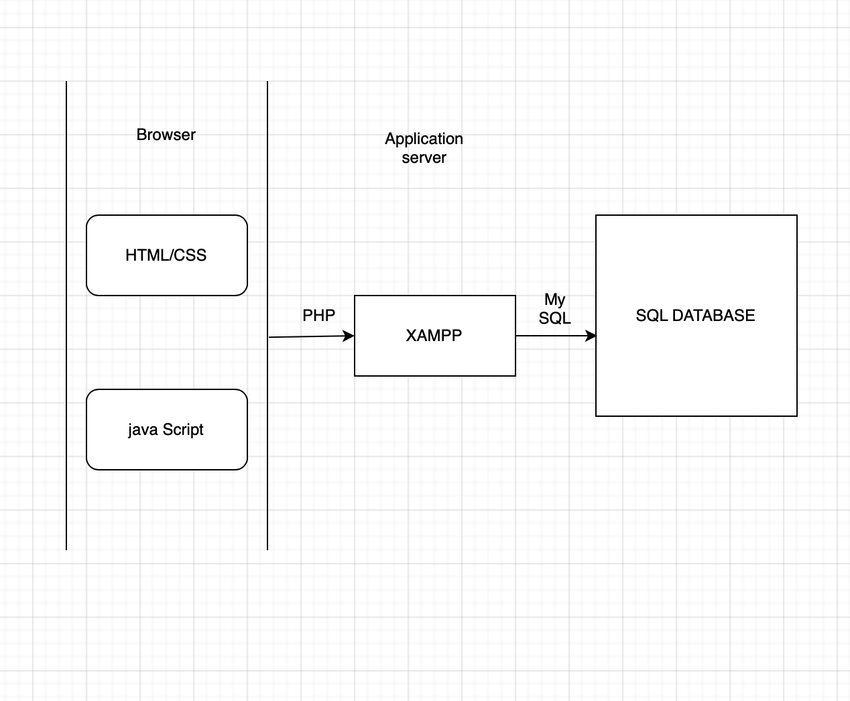

User Interface Browser is developed using Html, Css and JavaScript. Using Php we integrate user interface with My Sql Database via Xampp( Apache Tomcat server)

**2.2Product Features**

The main feature of the end product is to help the users to book rooms, do the payment and confirm the payment.

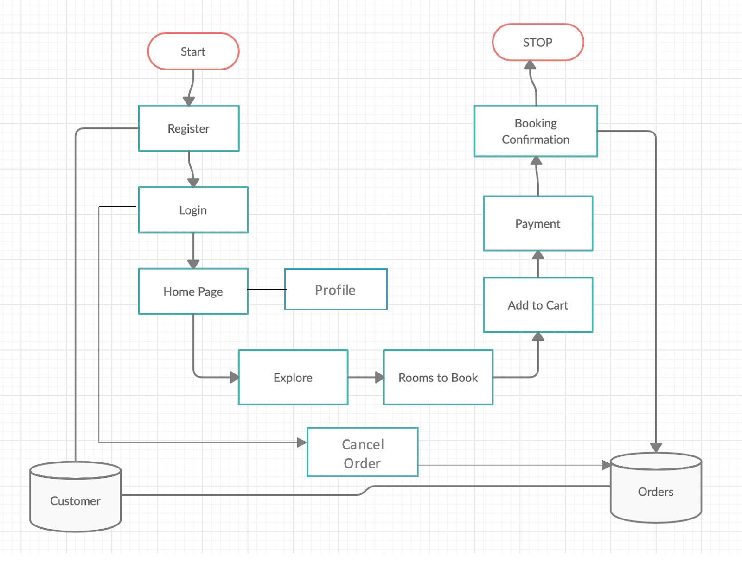

**Register**:

User needs to register before logging in. And after registering the user details will get stored in Customer table in the backend.

**Login**:

User can login at any time after getting registered. When any user tries to login, the details are exported from the table. Now user can get into Home page of the Hotel Website.

**Explore**:

User can explore the facilities motel provide. And then go for rooms to book.

**Rooms to Book & Add to cart**: After selecting their required rooms and days they are going to stay; they can add it to cart. On clicking on the cart option, the customer can see all the options he added to his cart.

**Payment**: When they are ready to book, they can click for payment and make their payment via PayPal. After Payment user will get points with respect to their transaction and these points can be used for benefits while making payment.

**Profile**: User can check the details like personal details and bonus points they have in their profile. We also allow the user to edit his details with a validation process from our side.

Booking Cancelation: The user has an option to cancel his booking and can easily get his refund

**Booking Confirmation**: User gets booking confirmation after successful payment.

**Database**: We will be having two tables in the backend, customer and the order table. Customer table has columns that includes, customer_id, customer_name, customer_email, customer_phone. And the order table has order_id, order_name, customer_id, order_date.

**2.3User Classes and Characteristics**

**User Classes**:

There are 2 types of users who use this project or have a role in this project.

**1.Admin**

The Admin has the right to almost each and every corner of the system and he is the one who manages system behaviour.

**2.End user**

He is the one who books the hotel room by using the website which has been developed by the admins who sell their services.

The main focus is to be put on the end user because the look and feel of the end user and also his interaction is what matters the most.

**2.4Operating Environment**

**2.4.1 Hardware Requirements:**

* Processor: Intel i3
* Space on disk: 160 GB
* Memory(RAM): 8 GB
* Stable Internet Connection.

**2.4.2 Software Requirements**

* Windows 7 or Windows or higher versions of OS
* Latest Web Browser. (Preferably, Mozilla Firefox, Google chrome)
* HTML, CSS,XAMPP and Apache tomcat server.
* JavaScript for client side scripting.
* MSSQL server 2008 for Database.

**2.5 Design and Implementation Constraints**

Design Constraint in our project is: The first page that the user sees is the login and the registration page, only after performing this action the user can see the other home and booking options. Because when the user has the access to book the rooms without an account then we will have further issues in the backend like asking the user to register at that moment.

Implementation Constraints can be like :

A user can’t change their username which is unique to a specific user and was linked to the database as primary key.

Parallel booking of rooms like when a customer books a room and it takes time in the backend while allocating a room meanwhile another end user parallelly books the room and if the room being booked is the last room available it’s a glitch again.

It being a web application is not as much as feasible when compared to a mobile application.

**2.6 User Documentation**

The user documentation will be provided in the about us link at the bottom of the homepage and users can also type in the textbox provided in the about us link or email the management  in case of any support required from the user perspective.

**2.7Assumptions and Dependencies**

It is assumed that the system developed should work absolutely fine under Xampp server and SQL database. The SRS will be updated in any unfavorable scenarios. The third party payment gateway we propose to implement, PayPal, should function in a sophisticated and robust manner. That’s one of the dependencies we intend to observe and maintain to its standards throughout the project even after the deployment as it holds a crucial value to the whole system. One more assumption to look out for is the user interface which we have been working on carefully and make sure that it is simple, fast and easily accessible to every customer.

**3.System Features**

**3.1 Registration**

1. The first page that the user sees is the registration and the login page. If it is his first time he needs to create an account, else can just login. The user needs to give the basic information for creating an account like his name, email, password and his phone number.
2. The customer has to give a strong password while registering, with the condition that we specify. After successfully registering, the data gets stored in the customer database table
3. To successfully achieve this, we are going to add a few text blocks, password validation code while developing and email validation.

**3.2 Login**

1. After successful registration, the user can login whenever he visits the website to book a room.
2. The user is asked for the username and password when he tries to login.
3. We get the details from the database and verify if the user is an existing user with us and allow him to login and perform necessary functions.

**3.3 Explore**

1. Explore is an option present on the home page. On clicking on this option, we can see the amenities that the motel provides.
2. We will be including amenities like wifi, spa, swimming pool, indoor courts, laundry inside and many more.

**3.4 Profile**

1. We are giving the user an option to change his profile details. He can just click on this profile buttons and see his profile details, like his username, email and phone number. He can use the edit button that we are adding on this page so as to change his details. We will add mobile or email validation in the process to make sure that an authenticated user only is making the change.

**3.5 Booking a room**

1. We are giving a variety of room options to the users to choose from. The options are luxury, premium and deluxe.
2. Along with the type of room, we are giving the option to choose the number of rooms they want to book.
3. They can also choose different type of room in a single booking with different amenities and different number of rooms for any type. This allows them to customize their booking.

**3.6 Add to cart**

1. After choosing the type and number of rooms for this booking, he can add his items to the cart.
2. This feature helps the user to save his choices and have a look later, change his preferences and book his room whenever he wants.
3. Adding to cart also helps the users to choose more than one room at a time.

**3.7 Payment**

1. After adding to his cart, the final step would be payment.
2. We are using the paypal gateway for performing the payment process. After the successful payment, the order details get stored in the order database table with the status if the payment is successful or not. And the user can see the final screen which shows up as a successful order and gets a receipt of it which is able to be downloaded.

**3.8 Cancel order**

1. The user can easily cancel his orders and get his refund. When he cancels the order the availability of the number of rooms also gets updated in the backend.

**3.9 Database**

1. We are using the php mysql database for storing the user and the order details. After creating the account, the user details gets stored in the customer table, while logging in the user details gets exported from the database.
2. After the payment is done, the order details are stored in the order table. The order table has a column with name as order status, it can have two values in it success and failure.
3. After successful payment, this column changes to success and successful message is shown to the end user, else he sees the failure message and has to try the payment process again.

**4.External Interface Requirements**

**4.1 User Interfaces**

We are trying to build the website with the best UI features and the most user friendly interface so that the user with minimal knowledge can just move around and perform necessary actions.

1. The first page which is the registration page, has text fields for username, email and password fields for password block. This page also has a login button in the top right corner button. If he is an existing user he can just click on that button and just login.
2. After logging in the user sees the home page, the homepage has various options like contact us, profile, book a room, my orders and explore. These options are inserted as buttons, on clicking on each option we move to a different page.
3. On clicking on the explore function, the user sees what all amenities the motel provides, we will include images that show all the amenities.
4. Next moving on to the “profile” button, the user can change his profile details. We will include an edit function to perform this action.
5. “Contact us” has the basic details like the phone number, email of the motel. Sometimes the customer can just call the motel and see if his booking has been confirmed or can enquire about any issue.
6. On clicking the “book a room” button, the user can see all the options we are giving them to book a room. We will be adding imaging along with text and a drop down to choose the number of rooms.
7. We have an “add to cart” under every room option in the book room page. On clicking on this option that particular room option goes to the cart. Therefore, the user can see all his chosen options under this cart.
8. On clicking on the “cart” option, he can see an option for payment which is “make a payment”. On clicking on this the paypal payment gateway is triggered and he can successfully finish the payment.
9. On clicking the “my orders” option, the user can see all his confirmed orders. He can see a cancel button for every order, and on clicking on that he can cancel his orders and get his refund.

Sample Screenshots:

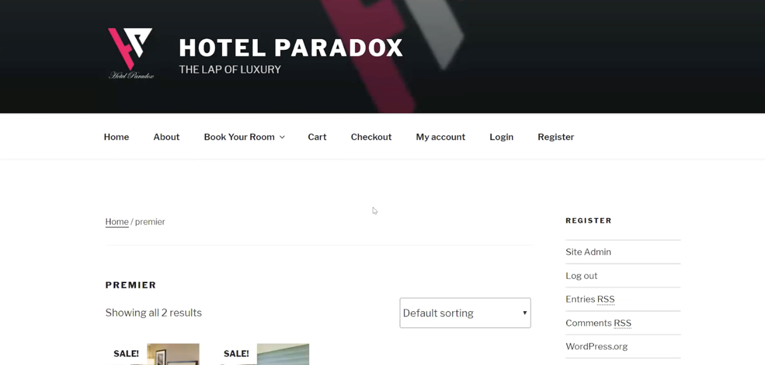

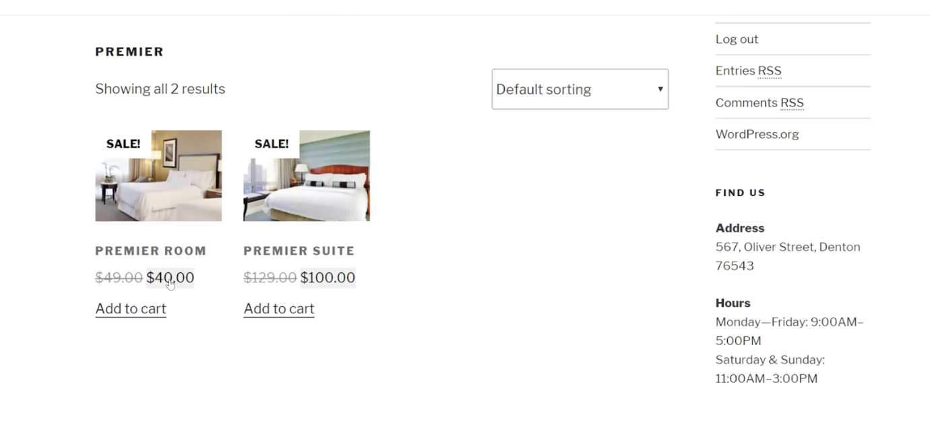

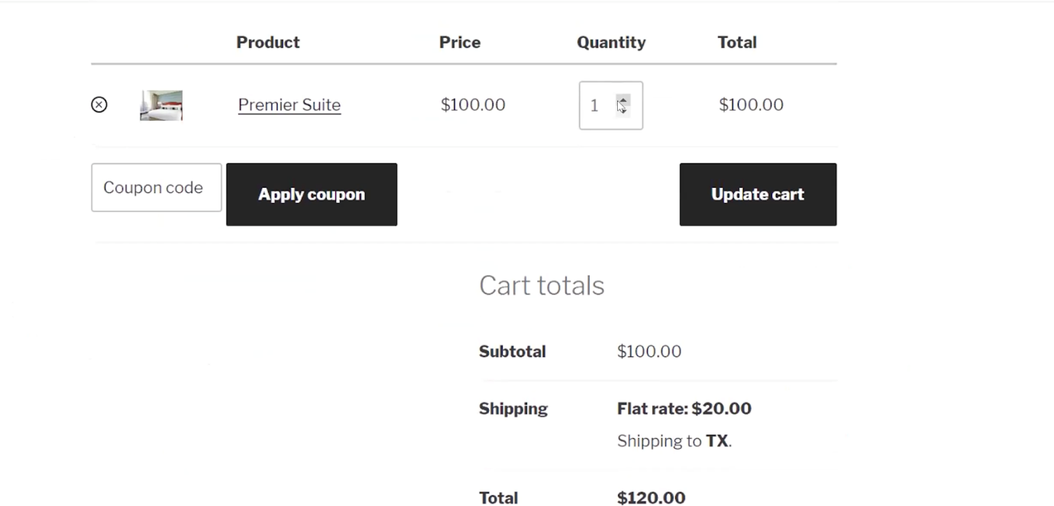

**4.2 Hardware Interfaces**

Monitor:1024*768

Processor:Intel i3 or AMD of the same level.

RAM:8gb

Space on disk:160

**4.3 Software Interfaces**

**Web Server:**

Apache Web Server.(XAMPP 7.2.33-1 Control Panel).

**Database Server:**

MySQL Database.

**Development Languages:**

HTML, CSS, JavaScript, PHP, Windows OS.

**4.4 Communications Interfaces**

HTTP / HTTPS is used in the system for connectivity over the internet which uses intranet correspondence TCP / IP protocols.

**5.Other Nonfunctional Requirements**

The non-functional requirements are basically our expectations on how the system should work after the deployment in real-time. Some of these include the following:

**5.1 Performance Requirements**

We aim to keep up the response time on our user interface for a better and faster usage for the customers. Also the throughput which is the number of requests served during the period should also be maintained.

It should be made sure that all the software and hardware requirements are met before accessing the services as mentioned above for better compatibility.

Our intention is to deploy a highly scalable system to meet customer’s expectations.

**5.2 Safety Requirements**

1. The admins backup the data from time to time. Incase of a database failure or loss of data, admin gets the data from backup.
2. Users need to provide passwords with rules specified at the time of registration.

**5.3 Security Requirements**

The passwords of the end users are even hidden from the admins.

The nonfunctional requirements will make sure that the system is protected from the malware attacks and prevent any unauthorized attempt to access restricted areas. For example, actions such as data breach, manipulation of data etc are to be prevented. This can be controlled if certain constraints as to who can  update, delete or edit data are introduced. Administrator login details should be assigned and kept in the inner circle of the developers. Some other security measures include using encryption in databases to prevent SQL injection attack, hashing algorithms hold a crucial role in this case.

**5.4 Software Quality Attributes**

Product possess few attributes like :

Flexibility:

User Interface is compatible with any browser.

Users can change their profile details except username whenever they want.

Availability:

Any user can register and book rooms on our website.

Maintainability:

Users can raise any queries in the about us page which goes to management.

Correctness:

Availability of rooms get updated frequently whenever user books or cancels

Portability:

Databases can be easily used in different user environments.

|  |
| --- |
| **6 The plan for implementing the project through three development phases:**  **Development Phase 1:** |
| UI - HOME PAGE |
| UI - REGISTRATION |
| DATA MODEL CREATION |
| UI - ABOUT & HOTEL OFFERINGS PAGE |
| DATABASE CUSTOMER DATA LINKING  **Development Phase 2:** |
| UI - ROOM BOOKING PAGES |
| DATABASE ORDERS AND CUSTOMERS LINKING |
| DATABASE ORDER CANCELING AND AVAILABILITY UPDATION IN THE BACKEND  **Development phase 3:** |
| UI-ADDING ORDERS TO CART |
| ORDER CONFIRMATION |
| TESTING |
| BUG FIXING-RISK MANAGEMENT |
| RE-EVALUATION |

6.2 Member contribution table

|  |  |  |  |
| --- | --- | --- | --- |
| Member name | Contribution description | Overall Contribution (%) | Note  (if applicable) |
| HEMANTH KUMAR KALUVAKURI | Backend Developer, Presentation | 20% |  |
| PRATHYUSHA DASARI | Backend Developer, Presentation | 20% |  |
| SRIHARSHA JALIGAMA | UI Developer, Documentation | 20% |  |
| RAHUL REDDY KANMANTHAREDDY | UI Developer, Documentation | 20% |  |
| ANURAG MUTYAPWAR | UI – Developer, Documentation | 20 % |  |